This document contains

Power rankings

Explanations of Helpers of Catan

Explorations of Cities and Knights and Seafarers with Helpers of Catan

Explorations of names, artwork, gender male female, race white African-American

Strategy of how to best use the helpers of Catan.

Note and disclaimer

Read the helpers of Catan rules before you read this. And this is not the definition of the rules. I have abridged some things so for any determinations, arguments, or definitive statements consult the rules.

Note on style/Style Note

When I want to indicate how many victory points, number of victory points, I write 9 VP. This means that I have 9 victory points. This is compared to writing 1 VP and 2VPs. For consistency, I write VP without the s for 1 or more than 1.

CK is used to indicate Cities and Knights/ Catan Cities and Knights/C&K.

TB is used to indicate Traders and Barbarians.

KP means Knight point/knight points. These are fleshed out in CK and Legend of the Conquerors. Common values are basic knight is 1 KP, strong knight is 2 KP, mighty knight is 3 KP. Mighty knight with cannoneer is 4 KP. Conquerors are up to 6 KP with 5 and 6 KP conquerors seen. Cannoneer adds 1 KP.

K means knight.

DCP means defender of Catan point

Face up knight card means FUKC

Face up knight card point means FUKCP

LA is largest army

LR is longest road.

RB is road building card.

S means Seafarers.

If you see an abbreviation and you don’t know what it means, look at this list at the top and you should figure out what it means and find what you need.

HC means Helpers of Catan. 1 HC or 1HC means 1st edition. 2 HC means 2nd edition.

NA means not applicable. This is because there are 2 cards in 2HC that have no equivalent in 1 HC—Caja and Karla.

|  |  |  |  |  |  |  |  |
| --- | --- | --- | --- | --- | --- | --- | --- |
| Helpers of Catan 1 | Helpers of Catan 2 | functionality | notes | CK | Strategy notes | Useless notes | Way to make the card more powerful |
| Nassir | Asla | Make someone give you a resource you want—you do have to give them something | Monopoly you get it for you don’t have to give something | Can you say give me a commodity? | Use card tracking. Useful for when you know someone has a resource like brick and they don’t want to trade with you. Useful with brick at the start of the game when no one has brick and suddenly someone has/gets brick but they cant spend it because they don’t have lumber in their hand at that point in time, but you do have lumber and 1 other resource so you give them that and take their brick. | No one has the resource you want. Or you have a resource that is in high demand and no one is going to refuse your trade offer and people want to trade with you. Is helpful because you can choose 2 people so you can be wrong. | Use on 3 players especially in 5-6 player game. They have to give you 2 resources and you give them 1. |
| William | Yngvi | Road substitute | Similar card Candamir and Vincent | Can you substitute for a ship? | Useful at the beginning of the game to build your 2nd road to get your 3rd settlement. | Always useful. You do have to have resources to build either wood brick wool to use this. | Substitute resource twice like wool and ore for road wool for lumber and ore for brick. |
| Marianne | Hilda | Get a resource if you don’t get anything | Similar to aqueduct | Can you take a commodity? | Useful when you don’t get anything on your turn either because it’s a rare roll like 2,3,11,12, or it’s a 4 5 9 10 but you aren’t on that resource or because it’s a 6 or 8 and the robbers on the resource | If you have a well distribution and you rarely have a number you don’t cover similar to aqueduct you will have to wait a long time to play Marianne. Could ask someone to block you so you can get rid of Marianne. | Either get 2 resources or say you can play Marianne if you have a low roll like instead of fail being get 0 resources, say fail is get 1 resources so you cant play Marianne if you get 2 resources, but you can if you get only 1 resource. |
| Louis | Högni | Move a road | Similar to Diplomat except Diplomat can be used offensively against another player | Ships and roads are interchangeable and functionally equivalent—functional equivalence | Useful for when you and someone else go for a location you race, you have a race, and you lose and they cut you off, say a race to a port, and so now your road is not useless you move rebuild your road. | If your roads are where you want them and you don’t get cut off. If you wanted to get rid of Louis, you could move a road, then move it again by playing Louis. | Move 2 roads, move opponent road (like diplomat), move closed roads maybe as long as nothing is isolated. |
| Sean | Thorolf | If you are over your discard limit you don’t have to discard |  | Your discard limit could be 7,9,11, 13 or maybe higher from treasure islands | Useful for when you have strong production and you have 9 10 cards or more and you haven’t had the opportunity to buy city walls to increase your discard limit, or where you have a higher discard limit even 13 cards but you are over say 15 16 17 18 cards, Sean saves you. | You have no 7s rolling or you are under your discard limit when a 7 rolls thankfully there is a fallback you get a resource. | You get more rewards the lower you are so say I have 4 cards I get 2 cards and if I have 6 cards I get to take 1 card. You could have a system like over cards like you have 10 over cards and if you spend at least over card, then you can get rid of Sean. So if discard is 11 I have 12 I use 1 over, then I have 9 left, then I have discard limit of 11 and I can have up to 20 cards safely. On the other hand, if at first I have 15 cards and discard is 11, then I spent 4 over and I have over left so next time, the discard limit is 11+6=17 cards so it rewards not going too far over the discard limit. |
| Candamir | Diara | Substitute development card ore wheat wool. You get to pick your development card from the top 3 cards. | Very powerful. Have never used but could be used for game winning conditions to get VP card at 9 points or knight card to get largest army on next turn or get road building to take longest road or to take harvest to get 2 resources you need to build a settlement or city to win the game (or road to win the game) | Not compatible with CK off the bat. You could say you can substitute a commodity for a city upgrade like instead of 3 paper, do 2 paper and 1 coin. And you could say when you draw a card next, you can look at top 3 cards. If you don’t draw a card after that you don’t get the benefit. | When you’re at 9 VP, Use Candamir to get VP card to get 10 VP. Take a road-building card to take longest road and go from 8 to 10 VP. Use Candamir to get year of plenty to build a settlement or city and win. Or use Candamir to get monopoly and win. Monopoly is useful with 3:1 or 2:1 port. | You can’t buy a development card, you don’t buy a development card, you don’t get a progress card in CK. None of the top 3 cards are what you want/none of the top 3 cards are useful/the card you are looking for is still at the bottom of the deck (at least not in the 3 you drew). | You can substitute 2 of 3 resources. You can look through top 5 cards. |
| Hilde | Ryan | Look at a player’s hand who has more VP than you and take 1 of their resources | You can see another players hand—very valuable like master merchant—you gain information. | Can you take a commodity? | Useful for when you’re behind. Can play it, then take Marianne. Cycling Marianne and Hilde. |  | You can take more cards if you are low and less if you are close for example if you have 3 VP and they have 7 or 8 VP you have 5 VP difference you take 2, whereas if you have 5 or 6 VP you are 2 or 3 or 1 away so you take 1 card. Also its annoying as a player in the lead to have some player that keeps taking your resource. This is similar to master merchant. Also similar to saboteur, wedding, etc. some say another player has more than you (wedding), or other have same or more than you (saboteur). For offensive cards, Same or more is more powerful than more.  You could have a card like Hilde where you take a progress card of a player more than you. Also you could change it to a card of my choice so if someone is taking my cards because they have less points than me, then I must give them 1 card, but I get to pick. |
| Jean | Stina | Trade at a 2 for 1 rate. | Very powerful. |  | I’ve used it where I produce a lot of grain, or brick, or sheep, or wool to trade for what I want. | If you don’t have a lot of 1 resource and or you have some of a resource but you want to use it for something like you might have 4 grain, but are going to use that for activating knights, building cities, settlements, etc. | Make it so that if you do a big trade like 6 for 3, or 8 or 4, or 10 for 5, then you can use Jean again for free. Also offer a 3 for 2 rate. So instead of 12 for 6 cards, (12/2), you would get 12/1.5 to get 8 cards. Really only applicable at large scales. So you have 2, 1.5/(3/2), 1.3/(4/3). With 4/3, you do 12 for 9. And you would have to deal with rounding like round down like you only get 9 cards at 12, if you turn in 11, divide it, you get 8.25, you get 8, not 9. |
| Lin | Digur | Move robber to desert. Get what the robber was blocking. | Makes the game funner. Useful for when you keep getting blocked by the robber. | What about moving the pirate ship? Do you get fish? Move the pirate off the board. Should you receive a commodity card? | You have a blocked hex. Play Lin and get the robber off the hex. | What if there is no robber?  What if you are not blocked by the robber? | If you have a city on the hex, you get a resource and a commodity. You can move the pirate and take some fish to trade in (see TB rules). Interacts well a lot with a lot of special scenarios for the robber like we stay home, Santa Claus Christmas, Easter Bunny for Easter, etc. where the special functionality of the robber is altered. |
| Vincent | Gregor | Discard 1 face up knight card |  |  |  |  |  |

Vincent discard 1 face up knight card to either build a settlement for 1 lumber 1 brick or build a city with 2 ore 1 grain.

This means largest army needs a rule change like longest road. Describe here

|  |  |  |  |  |  |  |  |
| --- | --- | --- | --- | --- | --- | --- | --- |
| Helpers of Catan 1 | Helpers of Catan 2 | functionality | notes | CK | Strategy notes | Useless notes | Way to make the card more powerful |

Vincent is like Medicine in CK. Vincent is incompatible with CK off the bat. How to extrapolate generalize Vincent to CK. There are no face-up knight cards in CK. What do face up knight cards represent? You can get rid of KP. For each KP you lose/downgrade/discard, you can perform that action. So the tradeoff is you paid 1 ore 1 wool for the KP or 1 ore 1 lumber for cannoneer, and you gain 2 resources. You spent 2 but now you take that back to get a discount of 2—wool and grain for settlement and ore and grain for city. So I could downgrade 3 KP K to 1 KP K giving me 2 discount points (DP). Then I could downgrade 1 2 KP K to 1 KP and 1 3 KP K to 2 KP, so 2+1+1=4 DP. So I can build 2 settlements and 2 cities, or 3 settlements and 1 city, or 3 cities and 1 settlement. Now the question is should you be allowed all that or should it be rate limited? Like should you be like you can you do that twice but not more, or you can do it all which I like, or you can only do it once and on next turn do it again, or you can only do it once but if you upgrade Vincent you can go from 1 DP/turn to 2 DP turn or upgrade Vincent from initial 2 DP per turn to 4 DP per turn?

I was thinking you discard defender of Catan thing (defender of Catan point DCP) to get that, but that doesn’t work, because 2 resources and 1 VP are not equivalent. I think it’s better to say you downgrade 1 KP to get 1 DP.

So you could have a situation where say I have largest army . so say I originally got 5 FUKCP and I have largest army. Then eventually James and John caught up to get 5 FUKCP and 5 FUKCP each. Well then I use Vincent and drop down to 4 FUKCP. Now its not like both James and John both get largest army (LA). No, its like neither gets it because there was not a point in time in which they had it and no one else had and only they had it. No, what happens is that largest army is defined by a point in time in which you have the largest army. Not tied for largest army. So since there is no point in time in which they have largest army, they do not get it. So if

|  |  |  |
| --- | --- | --- |
| James | John | Turn |
| 5 FUKCP | 5 FUKCP | 1 |
| 6 FUKCP | 5 FUKCP | 2 |

Then James would get LA. Then James does get LA in this case. Since there is a point in time in which James had the most, he is rewarded with and he does get LA. So the same precedent with longest road is used to establish the rule with LA.

Helpers of Catan are great for flexibility and allowing more paths for progress toward victory. More ways to get there.

2 new ones in 2nd edition of Helpers of Catan

Kaja and Carla.

|  |  |  |  |  |  |  |  |
| --- | --- | --- | --- | --- | --- | --- | --- |
| Helpers of Catan 1 | Helpers of Catan 2 | functionality | notes | CK | Strategy notes | Useless notes | Way to make the card more powerful |

Kaja is like Lin, but you take resource of your choice if robber in desert. So with Lin, if robber in desert, nothing happening. With Kaja, you don’t get to move the robber, unlike Lin, but benefit of Kaja is you get to pick a resource if robber in desert, whereas with Lin, you cant do anything or maybe move it to another desert but yeah. Kaja is easier to get of. Maybe take Kaja at first and if you keep getting blocked, take Lin.

Caja and Candamir are similar.

Development card swap—Carla. Cycle development cards. From a practical point of view and standpoint, Caja is easier because you don’t have to shuffle the entire deck after playing her. Now if you play in a computer, shuffle is easy. So in that case no difference play Candamir because Candamir more powerful. Carla does generalize to CK, Candamir does not. Carla is helpful when you get a card that you cant play that isn’t useful. Examples

Intrigue

VP card is always welcome except when you can be targeted by others because your ahead

Maybe you don’t want longest road because your out of roads (though if you allow ships you probably wont be out of roads with 30—15+15 roads/ships/links). I mean maybe you don’t want road building (RB).

Maybe you don’t want year of plenty because you have what you need.

Maybe you don’t want monopoly because 1 you don’t want to track what other people have and 2 they don’t have a resource that you need/want.

Maybe you don’t want knight card because the robbers not on your hex.

Maybe you don’t want engineer because you don’t have any cities without city walls or you’ve build all of your city walls.

Maybe you don’t want merchant because you already have merchant.

Maybe you don’t want a card because you cant play it at the moment

Maybe you don’t want mining because you’re not on ore.

Maybe you don’t want irrigation because your not on grain.

Maybe you don’t want inventor because you have the best layout. You could still do small changes like 4 for 5 instead of big changes like 3 for 5.

So I think I’m done. I explained helpers. I’ve explained how to play with CK and S for cards. I’ve explained strategy and how to make use of cards and how to maximize cards. I’ve explained when cards are useless. I’ve explained how to make cards more powerful.

Let’s show the 2 side by side

|  |  |  |
| --- | --- | --- |
| 1 Helpers of Catan | 2 Helpers of Catan | Action |
| Nassir | Asla | Forced people to trade with you |
| William | Yngvi | Build a road/ship with a substitute resource |
| Marianne | Hilda | Take a resource when you don’t get anything |
| Louis | Högni | Move a road/ship |
| Sean | Thorolf | Don’t discard if a 7 rolls and you are over your discard limit |
| Candamir | Diara | Buy a development card with a substitute resource and look at 3 cards from deck. |
| Hilde | Ryan | Look at player who has more VPs hand and take 1 card |
| Jean | Stina | Trade at 2 for 1 rate |
| Lin | Digur | Move robber to desert and collect resource of blocked hex |
| Vincent | Gregor | Discard FUKC to get 1 DP. A DP can be used to build a settlement for 1 lumber 1 brick or a DP can be used to build a city for 2 ore 1 grain. |
|  | Kaja | Take 1 resource of blocked hex. If robber is on desert, you pick the resource. |
|  | Carla | Put a development card back and take a new one. |

One note on Candamir and Diara. Let’s look at the language

|  |  |  |
| --- | --- | --- |
| Player | Candamir | Diara |
| Language | Use this advantage only 1 time during  your turn. When you buy a development card, you  may substitute 1 of the 3 resources with any 1 other  resource of your choice (for example, wool, grain, and  lumber). Additionally, when taking that development  card, instead of drawing 1 card at random from the top  of the development card deck, draw the top 3 cards and  choose 1 of them to keep. Return the 2 cards you did not  choose and reshuffle the development card deck. | When you buy a development card, you may substitute  1 of the 3 resources with any 1 other resource of your  choice. After paying, look at the top 3 development  cards in the stack. Keep 1 and shuffle the other 2 into  the deck.  Example: You want to buy a development card but have no ore.  So you pay 1 wool, 1 grain, and 1 brick instead. Then you look at  the top 3 cards, take 1, and reshuffle the rest. |

I like Candamir because it says reshuffle the deck. With Diara its less clear. I prefer the language of reshuffle the deck to put them back in the deck. I don’t know if they wanted to allow for sticking it somewhere in half up the deck or what to make it easier for playing, but I will play with Candamir logic and language and rules.

1HC has 10 helpers, 2 HC has 12 helpers.

Let’s show the 2 side by side with the official text.

|  |  |  |  |  |
| --- | --- | --- | --- | --- |
| 1 Helpers of Catan | 2 Helpers of Catan | Action | 1 HC rules | 2 HC rules |
| Nassir | Asla | Forced people to trade with you | Use this advantage only 1 time during  your turn. First declare a resource card type (wool,  for example). Next choose 1 or 2 opponents. Those  opponents must each give you 1 card of the declared  type (if they have it). Finally, for each resource card you  received in this way, you must give the player that gave it  to you 1 resource card of your choice in return. | Choose 1 resource type. Request this resource from 1 or  2 players, one after the other. If they have that resource,  they must give you 1. For each resource you receive,  give them 1 resource of your choice in return. You can  return the same resource if you wish.  Example: You choose ore as your 1 resource. First, you request it  from the Red Player. She gives you 1 ore, and you give her  1 wheat. Next, you request ore from the Blue Player. He gives you  1 ore, and you give him 1 ore back. |
| William | Yngvi | Build a road/ship with a substitute resource | Use this advantage only 1 time during  your turn. When building a road you may alter the  resources required to build that road. Instead of the  usual 1 lumber plus 1 brick, you may substitute  either the lumber or the brick with any 1 other  resource of your choice (for example,  1 lumber plus 1 wool). | When you build a road, you may substitute 1 lumber or  1 brick with any 1 other resource of your choice.  Example: You want to build a road but have no brick. So you  pay 1 lumber and 1 wool instead (or 2 lumber if you prefer). |
| Marianne | Hilda | Take a resource when you don’t get anything | Use this advantage on any turn. If  any production roll is not a “7” and you receive no  resources, take any 1 resource card of your choice. You  get to use this advantage before any other helper is used  by one of your opponents. | Use immediately after any player’s production roll. If  the roll is not a “7” and you receive no resources, take  any 1 resource card of your choice from the supply.  Example: The production roll for the turn is an “8.” However,  you have no settlements or cities on an “8” hex, so you receive no  resources. You play Hilda to take 1 resource of your choice from  the supply. Then exchange or flip her before the turn proceeds. |
| Louis | Högni | Move a road/ship | Use this advantage only 1 time during your  turn. You may remove 1 of your roads from the board  and rebuild it for free. Louis can only move a road where  1 of its 2 ends is not connected to any of your other  pieces (ignore opponents’ pieces when you are checking  connections).    When playing with Catan: Seafarers: If one of your  roads is connected at 1 end to one of your ships (as long as this ship  was built from the other direction), this road may also be removed and  rebuilt. This road and this ship are only considered “connected” when  your own settlement is built between them. | You may remove 1 of your end  roads and place it in another  location per standard CATAN rules.  Example: An “end road” means 1 end  does not connect to any of your own  pieces. The roads outlined here in white  are end roads. |
| Sean | Thorolf | Don’t discard if a 7 rolls and you are over your discard limit | Use this advantage on any turn. When any  production roll results in a “7,” you may immediately  use either of these advantages:  –If you have more than 7 resource cards in your hand,  you do not have to discard any cards.  –If you have 7 or fewer resource cards in your hand, you  may take any 1 resource of your choice from the supply. | Use when any player rolls a “7.” You MUST immediately  use Thorolf’s advantage. If you have more than  7 resources, do not return half to the supply. If you have  7 or fewer resources, take any 1 resource of your choice  from the supply. Then exchange or flip him before the  turn proceeds. |
| Candamir | Diara | Buy a development card with a substitute resource and look at 3 cards from deck. | Use this advantage only 1 time during  your turn. When you buy a development card, you  may substitute 1 of the 3 resources with any 1 other  resource of your choice (for example, wool, grain, and  lumber). Additionally, when taking that development  card, instead of drawing 1 card at random from the top  of the development card deck, draw the top 3 cards and  choose 1 of them to keep. Return the 2 cards you did not  choose and reshuffle the development card deck. | When you buy a development card, you may substitute  1 of the 3 resources with any 1 other resource of your  choice. After paying, look at the top 3 development  cards in the stack. Keep 1 and shuffle the other 2 into  the deck.  Example: You want to buy a development card but have no ore.  So you pay 1 wool, 1 grain, and 1 brick instead. Then you look at  the top 3 cards, take 1, and reshuffle the rest. |
| Hilde | Ryan | Look at player who has more VPs hand and take 1 card | Use this advantage only 1 time during your  turn. After your production roll has been resolved,  choose an opponent who has more victory points  showing on the board than you do. You may look  at that player’s hand of resource cards and take  1 resource card of your choice. | After your production roll has been resolved (all  resources given out), you may choose 1 opponent who  has more victory points than you. Look at their hand of  resource cards and take 1 of your choice. |
| Jean | Stina | Trade at 2 for 1 rate | During your turn, choose 1 resource type. You  may exchange that resource type with the supply at a 2:1  rate as often as you like during this turn (for example,  if you choose ore, you can give 2 ore to the supply and  take any 1 other resource of your choice). | Choose 1 type of resource and exchange it a ratio of 2:1  as many times as you like–all at once. This advantage is  NOT a 2:1 for the entire turn.  Example: You choose “brick” as the resource. Then you make  three 2:1 trades with 6 brick for 1 wool, 1 grain, and 1 ore. Then  exchange or flip Stina before your turn proceeds. |
| Lin | Digur | Move robber to desert and collect resource of blocked hex | Use this advantage only 1 time during your turn.  You may use it before or after resolving your production  roll. If the robber is on a terrain hex, you may move  the robber to the desert. After moving the robber this  way, you receive 1 resource of the type produced by the  vacated hex (for example, if the robber vacated a hills  hex, you receive a brick). | You may move the robber to the desert. If you do, you  receive 1 resource of the type produced by the terrain  hex that the robber left. You can play Digur before or  after resolving your production roll. If the robber is in  the desert, you cannot play Digur.  Example: The robber is blocking your “8” fields hex. Before you  roll the dice on your turn, you play Digur, move the robber to the  desert, and take 1 grain from the supply. |
| Vincent | Gregor | Discard FUKC to get 1 DP. A DP can be used to build a settlement for 1 lumber 1 brick or a DP can be used to build a city for 2 ore 1 grain. | Use this advantage only 1 time during your  turn. You may discard 1 knight card to reduce your  building costs as follows:  • Either build 1 settlement for 1 lumber plus 1 brick  • or upgrade a settlement to a city for 2 ore plus 1 grain.  The knight card that you discard must be one that you  have already played. | You may discard (place out of the game) 1 of your face-  up knight cards to choose 1 of the following actions:  •  Build a settlement for 1 lumber + 1 brick.  •  Build a city for 2 ore + 1 grain.  Example: You have 2 knights that you have previously played.  You want to build a city but don’t have enough grain. You  discard 1 of the knights and pay 2 ore + 1 grain to build a new  city. This knight is no longer counted toward your total for the  Largest Army. |
|  | Kaja | Take 1 resource of blocked hex. If robber is on desert, you pick the resource. |  | Take 1 resource card from the supply that match the  terrain hex that the robber currently occupies. If the  robber is in the desert, you can take a resource of your  choice from the supply.  Example: The robber is blocking a mountains hex. You play  Kaja and take 1 ore from the supply. |
|  | Carla | Put a development card back and take a new one. |  | You may place 1 of your unplayed development cards  at the bottom of the development card stack and  draw 1 from the top. Remember, you cannot play a  development card on the turn you receive it (except for  a VP card that brings your VP total to 10 or more). |

Another question can you substitute a commodity for a thing like can you build a road with William with 1 lumber 1 coin or with Candamir can you buy a development card with 1 ore 1 cloth 1 grain? I say yes.

Here is a table with pictures.

|  |  |  |  |  |
| --- | --- | --- | --- | --- |
| 1 Helpers of Catan | 1 HC image | 2 Helpers of Catan | 2 HC image | Action |
| Nassir |  | Asla |  | Forced people to trade with you |
| William |  | Yngvi |  | Build a road/ship with a substitute resource |
| Marianne |  | Hilda |  | Take a resource when you don’t get anything |
| Louis |  | Högni |  | Move a road/ship |
| Sean |  | Thorolf |  | Don’t discard if a 7 rolls and you are over your discard limit |
| Candamir |  | Diara |  | Buy a development card with a substitute resource and look at 3 cards from deck. |
| Hilde |  | Ryan |  | Look at player who has more VPs hand and take 1 card |
| Jean |  | Stina |  | Trade at 2 for 1 rate |
| Lin |  | Digur |  | Move robber to desert and collect resource of blocked hex |
| Vincent |  | Gregor |  | Discard FUKC to get 1 DP. A DP can be used to build a settlement for 1 lumber 1 brick or a DP can be used to build a city for 2 ore 1 grain. |
|  |  | Kaja |  | Take 1 resource of blocked hex. If robber is on desert, you pick the resource. |
|  |  | Carla |  | Put a development card back and take a new one. |

A note on the 2 HC images—the background is brown.

Compare



With



|  |  |  |  |  |
| --- | --- | --- | --- | --- |
| Names | | | | |
| 1 Helpers of Catan | 2 Helpers of Catan | 1 HC name | 2 HC name |  |
| Nassir | Asla | African-American male | White female | Change race from African-American to white, gender from male to female |
| William | Yngvi | White male | White male |  |
| Marianne | Hilda | White female | White female |  |
| Louis | Högni | White male | White male |  |
| Sean | Thorolf | White male | White male |  |
| Candamir | Diara | White male | African-American woman | Change race from white to African-American, gender from male to female |
| Hilde | Ryan | White female | White male | Change gender from female to male |
| Jean | Stina | White female | White female |  |
| Lin | Digur | Chinese female | African-American male | Change race from Chinese to African-American, gender from female to male |
| Vincent | Gregor | White male | White male |  |
|  | Kaja |  | White female |  |
|  | Carla |  | White female |  |

How many didn’t change

|  |  |  |  |  |
| --- | --- | --- | --- | --- |
| Names | | | | |
| 1 Helpers of Catan | 2 Helpers of Catan | 1 HC name | 2 HC name |  |
| William | Yngvi | White male | White male |  |
| Marianne | Hilda | White female | White female |  |
| Louis | Högni | White male | White male |  |
| Sean | Thorolf | White male | White male |  |
| Jean | Stina | White female | White female |  |
| Vincent | Gregor | White male | White male |  |

6 did not change. Of the 6 that did not change, 4 were white male and 2 was white female—Hilda and Marianne and Jean and Stina.

2 were new

|  |  |  |  |  |
| --- | --- | --- | --- | --- |
| Names | | | | |
| 1 Helpers of Catan | 2 Helpers of Catan | 1 HC name | 2 HC name |  |
|  | Kaja |  | White female |  |
|  | Carla |  | White female |  |

That leaves 4 that changed.

|  |  |  |  |  |
| --- | --- | --- | --- | --- |
| Names | | | | |
| 1 Helpers of Catan | 2 Helpers of Catan | 1 HC name | 2 HC name |  |
| Nassir | Asla | African-American male | White female | Change race from African-American to white, gender from male to female |
| Candamir | Diara | White male | African-American woman | Change race from white to African-American, gender from male to female |
| Hilde | Ryan | White female | White male | Change gender from female to male |
| Lin | Digur | Chinese female | African-American male | Change race from Chinese to African-American, gender from female to male |

2 changed race African-America and white and male—Nassir and Candamir. 1 changed race from Chinese to African-American. 2 changed from male to female—Nassir and Candamir. 2 changed from female to male—Hilde and Lin.

3 changed race. 4 changed gender.

|  |  |  |  |
| --- | --- | --- | --- |
| Race | | | |
| Race | 1 HC Count | 2 HC count | Change |
| White | 8 | 10 | Increase +2 |
| African-American | 1 | 2 | Increase+1 |
| Chinese | 1 | 0 | Decrease-1 |
| Total | 10 | 12 | +2 |

Gender

|  |  |  |  |
| --- | --- | --- | --- |
| Gender | | | |
| Gender | 1 HC Count | 2 HC count | Change |
| Male | 6 | 6 | Increase +0 |
| Female | 4 | 6 | Increase+2 |
| Total | 10 | 12 | +2 |

Names

|  |  |  |  |  |
| --- | --- | --- | --- | --- |
| Names | | | | |
| 1 Helpers of Catan | 1 HC name | 2 Helpers of Catan | 2 HC name | Change |
| Nassir | Not great name | Asla | okay | better |
| William | Good | Yngvi | Hard to spell, hard to pronounce | worse |
| Marianne | Not great to okay | Hilda | Okay | better |
| Louis | Okay | Högni | Hard to pronounce, what is with ö?, hard to spell | worse |
| Sean | Okay | Thorolf | Not great name | worse |
| Candamir | Okay | Diara | Not great name | worse |
| Hilde | Not great | Ryan | okay | better |
| Jean | Okay | Stina | Not great to okay | worse |
| Lin | okay | Digur | Not great | worse |
| Vincent | Okay | Gregor | okay |  |
|  |  | Kaja | Not great | New not great |
|  |  | Carla | Not great | New not great |

So we see with the names

|  |  |  |
| --- | --- | --- |
|  | Count |  |
| Better in 2 HC than in 1 HC | 3 |  |
| Worse in 2 HC than 1 HC | 6 |  |
| unchanged | 1 |  |
| New not great | 2 |  |
| Total | 12 |  |

The names got generally worse from 1 HC to 2 HC.

Do a chart comparing how powerful they are.

Order them.

Ordered

A1 Nassir

A2 William

A3 Marianne

A4 Louis

A5 Sean

A6 Candamir

Ordered ones=Nassir, William, Marianne, Louis, Sean, Candamir

Unordered ones

Hilde

Jean

Lin

Vincent

Kaja

Carla

I order them as

|  |  |
| --- | --- |
| Rank | Name |
| 1 | Nassir |
| 2 | William |
| 3 | Marianne |
| 4 | Louis |
| 5 | Sean |
| 6 | Candamir |
| 7 | Hilde |
| 8 | Jean |
| 9 | Lin |
| 10 | Vincent |
| 11 | Kaja |
| 12 | Carla |

Ordering them by power

Powerful and flexible

Marianne

Jean

Candamir

Vincent

Carla

William

Powerful but situational and not always useful

Hilde—have to be behind

Lin—have to be robbed—powerful but only when on a hex other than the desert—actually powerful and flexible

Nassir—you have to have a resource to give, and someone has to have the resource you wants

Sean—powerful but only when a 7 is rolled

Flexible but not powerful

Kaja

Not great only useful in highly specific situations

Louis

Power ranking

1—powerful

Marianne, Jean, Candamir, Vincent, Carla, William

2—middle powered

Hilde, Lin, Nassir, Sean, Kaja

3—weak

Louis

I would say the most powerful are Candamir and Marianne.

Other ways to rank them

How easy it is to cycle them, how useful they are, etc. For example, Kaja is easy to cycle but not very powerful. Sean is powerful—keeps cards so you don’t have to discard some—but if no 7s roll then is useless.

I will assume CK for the following.

Summary again

Candamir—powerful. Dependent upon drawing progress cards and/or having commodities to purchase city improvements.

Hilde—useful in 2 ways—get a card and see opponents hand. Dependent on another player being ahead and to play it well for the player ahead of you to have a resource that you want like brick.

Jean—powerful and not dependent on any in-game event like roll a 7, draw a progress card, get the robber, etc. but only really useful when you have a lot of 1 resource

Lin—useful and flexible, not that powerful. Dependent on where the robber is, the robber not being in the desert, and ideally for strong play the robber is on your hex and you are unblocking your hex

Louis—powerful when you get cut off but otherwise useless. Or when you change your mind and want to reorganize. No new things being added, though. Like other cards give you something new like a new resource. Louis merely rearranges what is already on the board.

Marianne—dependent on no 7, no resources from production. Useful because you get a new card and especially powerful because you get to pick the new resource

Nassir—not a great card. Potentially powerful, but requires an opponent to have a resource that you want.

Sean—depends on rolling a 7. Powerful to save you from discarding massive amounts of cards.

Vincent—downgrade 1 KP. Like Louis, you are rearranging, not getting anything new. However, powerful as building a settlement increases your production and building a city means better production or commodities.

William—powerful. Focused on road-building. You have to have either wood or brick or wool.

Carla—cycling progress cards is powerful. However, dependent on cycling progress cards.

Kaja—like Lin dependent on the robber.

A note on Marianne. You get resources from the aqueduct and Marianne. The aqueduct does not shut down Marianne so you are always stuck with Marianne. The card means you get no cards from the production roll.

I think I have analyzed this as much as can be.

Common groups

New—Carla and Kaja 2

Good sounding names—Candamir, Jean,Lin,Louis,Sean,Vincent,William,Asla, Hilda, Ryan, Gregor 11

Bad names—Marianne,Nassir,Yngvi,Högni, Thorolf,Diara,Stina,Digur,Kaja,Carla,Hilde 11

Hilde (1HC) and Hilda (2 HC) are similar names. Change e to a.

Chosen names

|  |  |  |  |  |  |
| --- | --- | --- | --- | --- | --- |
| Names | | | | |  |
| 1 Helpers of Catan | 1 HC name | 2 Helpers of Catan | 2 HC name | Change | Chosen name |
| Nassir | Not great name | Asla | okay | better | Asla |
| William | Good | Yngvi | Hard to spell, hard to pronounce | worse | William |
| Marianne | Not great to okay | Hilda | Okay | better | Hilda |
| Louis | Okay | Högni | Hard to pronounce, what is with ö?, hard to spell | worse | Louis |
| Sean | Okay | Thorolf | Not great name | worse | Sean |
| Candamir | Okay | Diara | Not great name | worse | Candamir |
| Hilde | Not great | Ryan | okay | better | Ryan |
| Jean | Okay | Stina | Not great to okay | worse | Jean |
| Lin | okay | Digur | Not great | worse | Lin |
| Vincent | Okay | Gregor | okay |  | Vincent I would have picked Gregory over Vincent if they had Gregory instead of Gregor |
|  |  | Kaja | Not great | New not great | Kaja |
|  |  | Carla | Not great | New not great | Carla |

I will use the canonical names for the following categories.

Powerful Powerful

Candamir,Hilda

Powerful

Jean, Vincent, Carla, William

2—middle powered

Ryan, Lin, Asla, Sean, Kaja

3—weak

Louis

Now I think they increased the power of woman and African-American and decreased the power of men and white in 2 HC.

Case in point the top 6 most powerful

Female—Carla, Stina, Diara,Hilda 4

Male—Gregor,Yngvi 2

For 2 HC compared to first edition

Female—Jean,Marianne 2

Male—Candamir,Vincent,William 3 (Carla is not present)

So 0.66 0.33 in 2 HC compared to 0.4 0.6 in 1 HC where first number is fraction female and second number is fraction male.

What about race?

White—Carla,Stina,Hilda,Grego,Yngvi 5

African-American Diara though not that she is one of the most powerful 1

For 2 HC compared to

White—Jean, Marianne, Candamir, Vincent, William 5

Okay maybe white didn’t get weaker. But the following are true. Female got stronger. Male got weaker. African-American got stronger.

If you wanted to, you could look at weaker to see if that holds up. Most of the weaker ones are male.

Also, you could do a weighted average like assign 3 to strong, 2 to medium 1 to weak, and compute the centroid for each group.

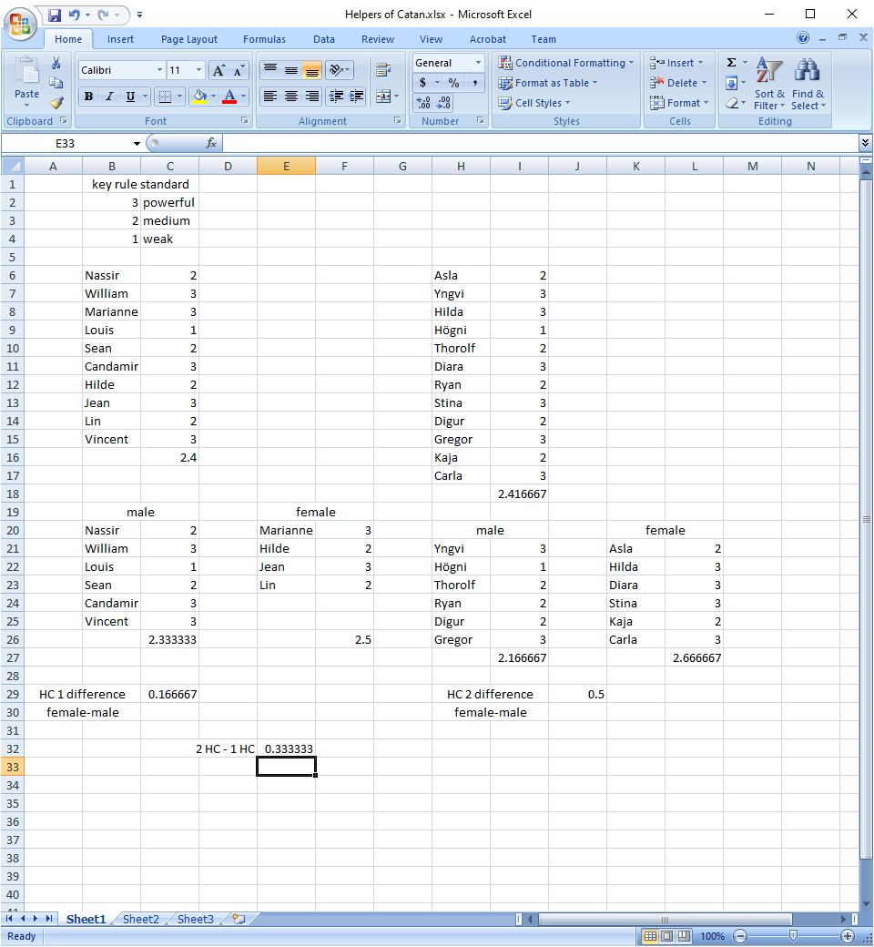

Several interesting things to note here. One is that 2 HC has 2.416 which is slightly higher than 1 HC 2.4 Kaja and Carla helped pull it up.

Second, female average is higher in 1 HC and 2 HC. Third, female average is significantly higher in 2 HC than in 1 HC. We compute female-male for both editions. 2 HC’s is 0.33 higher.

Second, even if Hogni/Louis was 2 instead of 1, 2 HC female would still be higher than 1 HC.

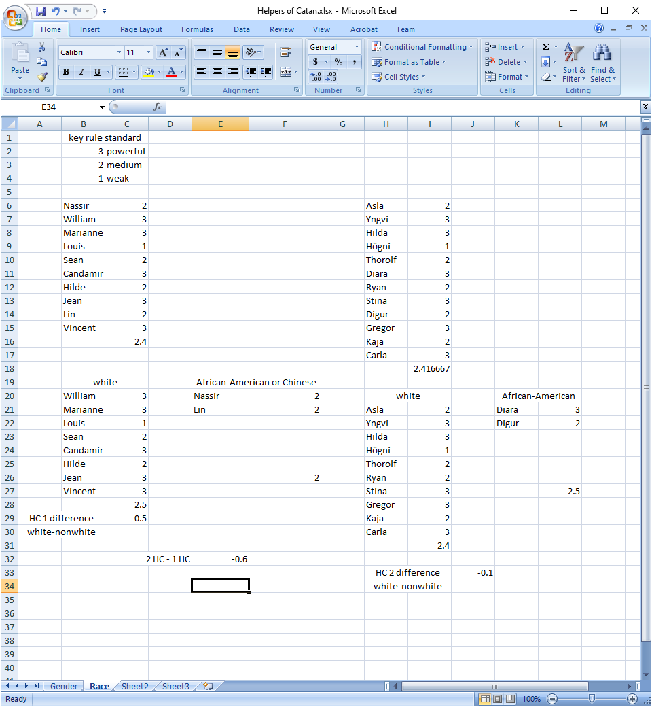

So, white-nonwhite is -0.6. that means nonwhite-white is 0.6 which means white got weaker and nonwhite got stronger.